**Title** : Growth performance of ***Tagetes erecta*** in soil and floating bed cultivation.

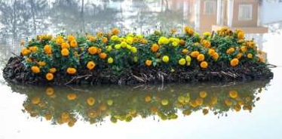

**Abstract**

The present investigation entitled, " Growth Performance of *Tagets erecta* in Soil and Floating bed Cultivation “ was carried out at University of Barishal campus. The layout of the experiment was laid down as two treatments(soil and floating condition) along with 3 replication of two variety of marigold : *'Pusa Narangi Gainda'*(orange Color- variety-1) and *'Pusa Basanti Gainda'*( yellow color- variety -2 ) . Most of the growth parameters was greater in floating condition than soil condition for both variety. It is recomended to use floating bed condition for commercial cultivation of Marigold as a substitute for soil cultivation as it gives better result.

**Introduction**

•Marigold (*Tagetes erecta*) is an important commercial ornamental annual flower which belongs to the family “Asteraceae (Compositae)”.

•It is a herbaceous plant, whose height ranges from 30–110 cm.

•Most species have pinnate green leaves.

•The root is cylindrical, pivoting, with a fibrous and shallow branching system.

•The stem is straight, sometimes ridged, smooth or slightly with villi, cylindrical, oval and herbaceous to slightly woody, with resin channels in the bark, which are aromatic when squeezed.

•Blooms naturally occur in golden, orange, yellow, and white colors, often with maroon highlights.

•Floral heads are typically (1-) to 4–6 cm diameter, generally with both ray florets and disc florets.

Farmers cultivate okra, red amaranth, cucumber, Indian spinach, turmeric, and aroid on organic floating beds made of mainly water hyacinth.

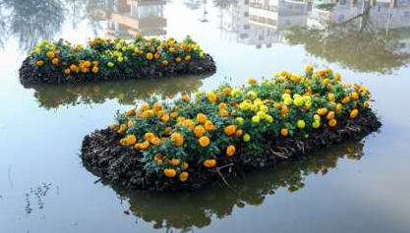 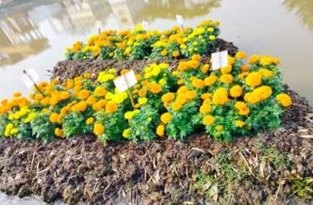

**Materials**:

**1**.**For preparing floating bed**:

•Water Hyacinth

•Cow dung

•Compost

•Topapana

•PVC pipe

•Bamboo

•Rope

2)Marigold seedling- 108 piece

3)Cow dung- 50 kg

4)Register Notebook- 1 piece

5) Measuring tape -1piece

**Methodology**

**(In Soil):**

•First ,the land was ploughed , cleaned of any weeds , leveled and raised rows were made for well drainage.

• To increase fertility of soil, at time of last ploughing ,well decomposed cow dung was mixed.

•The ratio of cow dung and soil was 1:2.

•1month old seedling of marigold of two variety- *'Pusa Narangi Gainda'(*orange Color- variety-1) and *'Pusa Basanti Gainda'(* yellow color- variety -2) from nursery was taken for transplantation.

•After that, the seedling was planted on soil bed at 18-December-22 and watered daily.

Variety :1 Variety:2

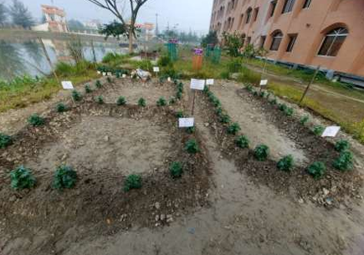 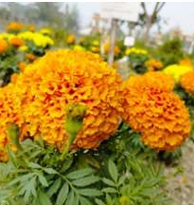 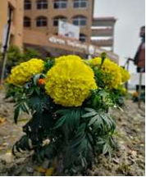

**(Floating Bed:)**

• First dense, mature and long size water hyacinths was collected.

•A square structure with plastic PVC pipe was made as a support for the floating bed and net was placed on the pipe structure and was tied by rope on all corners.

• Water hyacinths was laid on the net and this process continued until the desired height of the bed was obtained.

•A layer of mixed soil made up with decomposed topapana , water hyacinth and cow dung was placed on the bed .

• 1 month old seedlings was planted at a distance of 6 inch in a row and the seedlings was watered generously daily.

•Then every 15 DAT( Days After Transplanting) for more than two month ,the growth performance between the soil condition(SC) and floating condition(FC) in various parameters as:

* plant height
* number of branch
* number of flower bud
* number of flower
* number of leaflet
* root length
* leaf area
* leaf size
* flower diameter
* stem diameter
* days of flower initiation
* days of full blooming was compared and then results was recorded and analysed.

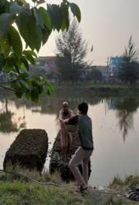 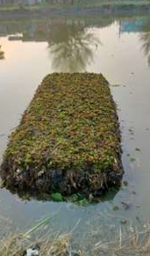 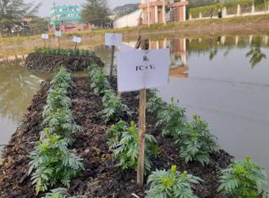

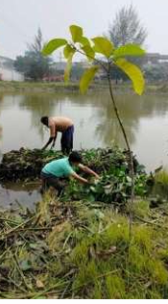 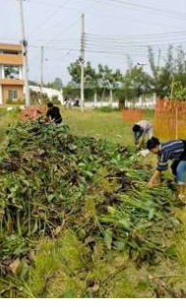 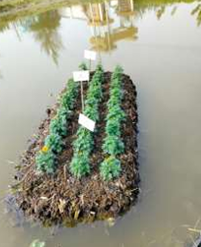

**Result and Discussion**

* **Plant Height(cm)**

|  |  |  |  |  |  |
| --- | --- | --- | --- | --- | --- |
| **Growing Condition** | **Variety** | **Day of Transplanting** | **15 DAT** | **30 DAT** | **45 DAT** |
| **Floating**  **Condition**  **(FC** | V1 | 21.15 | 28.89 | 31.88 | 33.84 |
| V2 | 19.66 | 23.7 | 31.05 | 34.69 |
| **Soil**  **Condition**  **(SC** | V1 | 22.6 | 28.91 | 26.87 | 25.56 |
| V2 | 17.89 | 25.56 | 28.96 | 34.52 |

Table-1: Average plant height

The result presented in table -1 is the average plant height of 3 replications for each variety .

It is clear from the Table-1 that, the total average height of seedling

* at 15 DAT , SC of V1 is the highest(28.91);
* at 30 DAT , FC of V1 is the highest(31.88);
* at 45 DAT ,FC of V2 is the highest(34.69).

So ,overall, average plant height is better in FC than in SC

* **Number of leaflet**

|  |  |  |  |  |  |
| --- | --- | --- | --- | --- | --- |
| **Growing Condition** | **Variety** | **Day of Transplanting** | **15 DAT** | **30 DAT** | **45 DAT** |
| **Floating**  **Condition**  **(FC** | V1 | 45 | 105 | 488 | 407 |
| V2 | 38 | 85 | 442 | 475 |
| **Soil**  **Condition**  **(SC** | V1 | 51 | 71 | 155 | 261 |
| V2 | 51 | 69 | 150 | 229 |

Table-2: Average number of leaflet.

•The result presented in table -2 is the average number of leaflet of 3 replications for each variety .

•It is clear from the Table-2 that, the total average number of leaflet of seedling

* at 15 DAT , FC of V1 is the highest(105);
* at 30 DAT , FC of V1 is the highest(488);
* at 45 DAT ,FC of V2 is the highest(475).

So ,overall, average number of leaflet is better in FC than in SC. Table-2: Average number of leaflet.

* **Number of flower bud:**

|  |  |  |  |  |  |
| --- | --- | --- | --- | --- | --- |
| **Growing Condition** | **Variety** | **Day of Transplanting** | **15 DAT** | **30 DAT** | **45 DAT** |
| **Floating**  **Condition**  **(FC** | V1 | 7 | 11 | 22 | 21 |
| V2 | 5 | 8 | 13 | 20 |
| **Soil**  **Condition**  **(SC** | V1 | 3 | 7 | 20 | 18 |
| V2 | 3 | 7 | 14 | 8 |

Table-3: Average number of flower bud

•The result presented in table 3 is the average number of flower bud of 3 replications for each variety .

•It is clear from the Table-3 that, the total average number of leaflet of seedling

* At 15 DAT , FC of V1 is the highest(11);
* At 30 DAT , FC of V1 is the highest(22);
* At 45 DAT ,FC of V1 is the highest(21)

So ,overall, average number of flower bud is better i n FC than in SC.

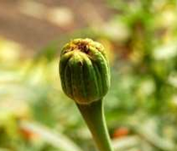

Flower bud

**Conclusion**:

On the basis of the result obtained from the present investigation it can be concluded that ,

* The floating bed method of cultivation was found most effective with respect to most of the growth parameters including maximum flower yield of Marigold (*Tagetes erecta).*
* Floating cultivation can be used as a substitute for soil cultivation of Marigold as it gives better result.
* Floating bed method can be used for ornamental purpose by using unused water bodies This method can be recommended to farmers for cultivation of Marigold- (*Tagetes erecta)*

**Reference:**

[1]Sardoei, A.S., Roien, A., Sadeghi, T., Shahadadi, F. and Mokhtari, T.S., 2014. Effect of vermicompost on the growth and flowering of African Marigold (Tageteserecta). American Eurasian Journal of Agricultural and Environmental Sciences, 14, pp.631-635.

[2]Singh, Y., Verma, P. and Verma, J.P., 2008. Effect of NPK, Spacing and MH on Flower Yield of African Marigold (Tageteserecta L.) CV. PNG. Annals of Horticulture, 1(1), pp.27 31.

[3]Naidu, J.H., Ashok, P., Sekhar, R.C. and Sasikala, K., 2014. Effect of plant growth retardants and spacings on vegetative growth and flower yield of African marigold (Tageteserecta L) cvPusaNarangiGainda. International Journal of Farm Sciences, 4(2), pp.92 99.

[4]Kumar, A. and Kumar, A., 2017. Effect of bio-fertilizers and nutrients on growth and flower yield of summer season African marigold (Tageteserecta L.). Plant Archives, 17(2), pp.1090-1092.

[5]Pal, P. and Ghosh, P., 2010. Effect of different sources and levels of potassium on growth, flowering and yield of African marigold (Tageteserecta Linn.) cv.‘Siracole’.

[6]Jadhav, P.B., Alka, S., Mangave, B.D., Patil, N.B., Patel, D.J., Dekhane, S.S. and Kireeti, A., 2014. Effect of organic and inorganic fertilizers on growth and yield of African Marigold (Tageteserecta L.) Cv. PusaBasantiGainda. Annals of Biological Research, 5(9), pp.10-14.

[7]Singh, A.K., Kumar, U.D.I.T. and Kumar, A.R.U.N., 2015. Effect of planting date and spacing on performance of marigold (Tageteserecta Linn) cv. PUSA NARANGI under North Bihar agro-ecological conditions. International Journal of Forestry and Crop Improvement, 6(1), pp.16-20.

[8]Riaz, A.T.I.F., Younis, A., Taj, A.R., Karim, A., Tariq, U., Munir, S. and Riaz, S.I.T.W.A.T., 2013. Effect of drought stress on growth and flowering of marigold (Tageteserecta L.). Pakistan Journal of Botany, 45(S1), pp.123-131